LAPORAN
PORTFOLIO ASSOCIATE DATA SCIENTIST

SUPERVISED LEARNING

Disusun Oleh:
Drs. Herwin, M.Pd.

FAKULTAS ILMU KEOLAHRAGAAN
UNIVERSITAS NEGERI YOGYAKARTA
18 DESEMBER 2021
- Dataset ini merupakan informasi terkait pelanggan apakah ingin membeli atau tidak terhadap promo barang yang ditawarkan. Diambil beberapa informasi untuk menentukan pelanggan tersebut akan membeli atau tidak.
X1 : Gender
x2 : Age
X3 : Estimated Salary
Y : Purchased (0: Tidak Membeli, 1: Membeli)
Data Understanding

Load Library

#library data manipulation
- import pandas as pd
- import numpy as np
#library data visualisasi
- import matplotlib.pyplot as plt
- import seaborn as sns
#library data modelling
- from sklearn.preprocessing import StandardScaler
- from sklearn.model_selection import train_test_split
- from sklearn.svm import SVC
- from sklearn.linear_model import LogisticRegression

#library data evaluasi
from sklearn.metrics import classification_report
from sklearn.metrics import confusion_matrix
#library export modelling
import pickle

- import pandas as pd
- df = pd.read_csv('Dataset12_Social_Advertising.csv')
- df.head(5)
Load Dataset

 | User ID | Gender | Age | EstimatedSalary | Purchased
0 | 15624510 | Male | 19 | 19000 | 0
1 | 15810944 | Male | 35 | 20000 | 0
2 | 15668575 | Female | 26 | 43000 | 0
3 | 15603246 | Female | 27 | 57000 | 0
4 | 15804002 | Male | 19 | 76000 | 0
Validation Dataset

#dimension of dataset
- df.shape

(400, 5)

#deskriptif of dataset
- df.describe().T
Validation Dataset
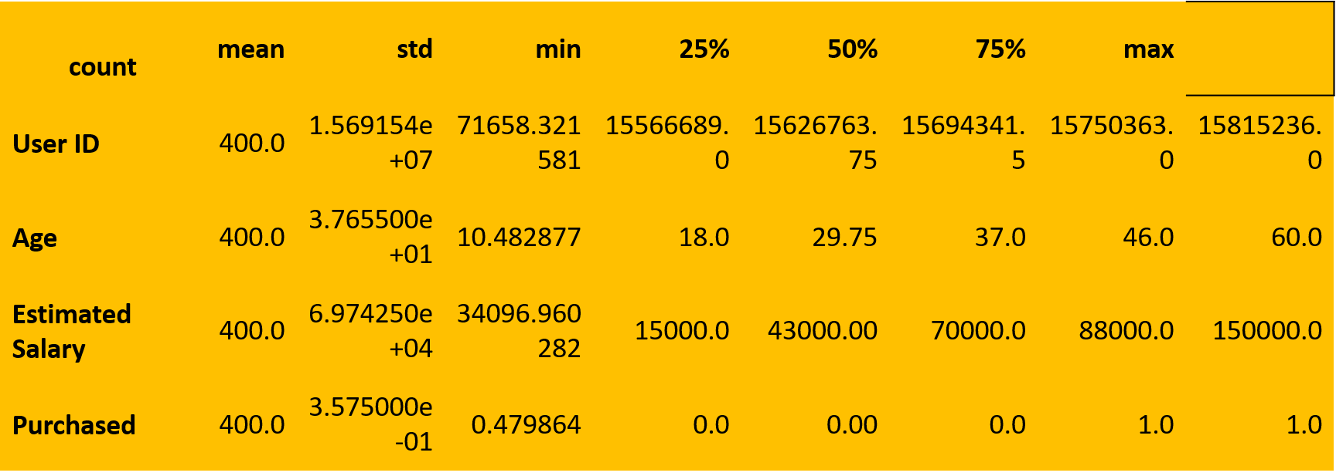

Validation Dataset

#information of dataset
- df.info()
<class 'pandas.core.frame.DataFrame'> RangeIndex: 400 entries, 0 to 399 Data columns (total 5 columns): # Column Non-Null Count Dtype --- ------ -------------- ----- 0 User ID 400 non-null int64
1 Gender 400 non-null object
2 Age 400 non-null int64
3 EstimatedSalary 400 non-null int64
4 Purchased 400 non-null int64
dtypes: int64(4), object(1) memory usage: 15.8+ KB

Objective Dataset
- df.head(5)
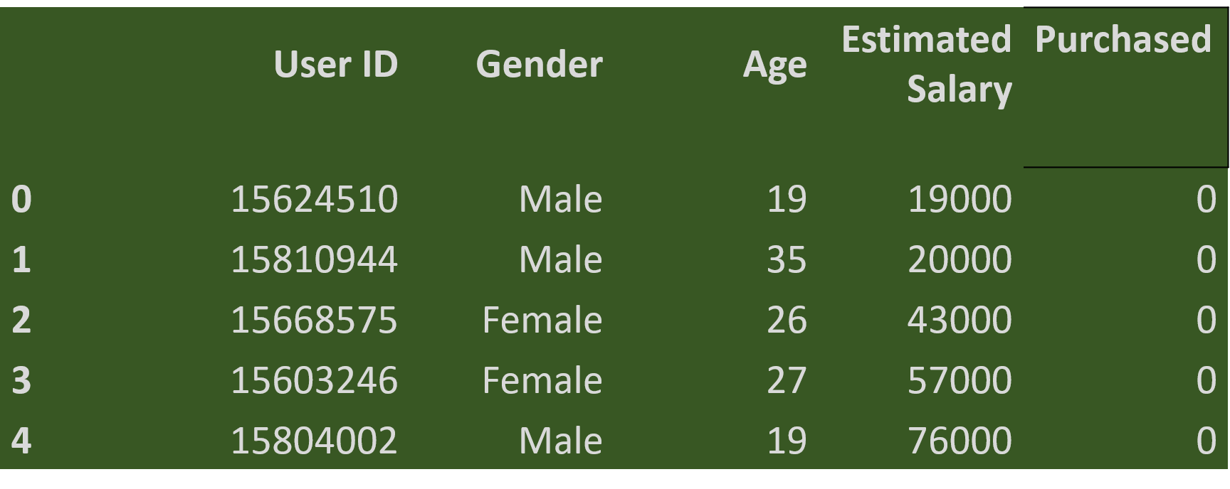

#drop user ID
- df = df.drop(['User ID'], axis=1)
- df.head(5)
Objective Dataset

 | Gender | Age | EstimatedSalary | Purchased
0 | Male | 19 | 19000 | 0
1 | Male | 35 | 20000 | 0
2 | Female | 26 | 43000 | 0
3 | Female | 27 | 57000 | 0
4 | Male | 19 | 76000 | 0

Cleaning of Dataset

- df.isnull().sum()

Gender 0
Age 0 EstimatedSalary 0 Purchased 0
dtype: int64

#option 1
# df = df.dropna()
# df.isnull().sum()
#option 2
- df['Gender'] = df['Gender'].fillna(df['Gender'].mode()[0])
- df['Age'] = df['Age'].fillna(int(df['Age'].mean()))
- df.isnull().sum()
Objective Dataset

Gender 0
Age 0
EstimatedSalary 0
Purchased 0
dtype: int64

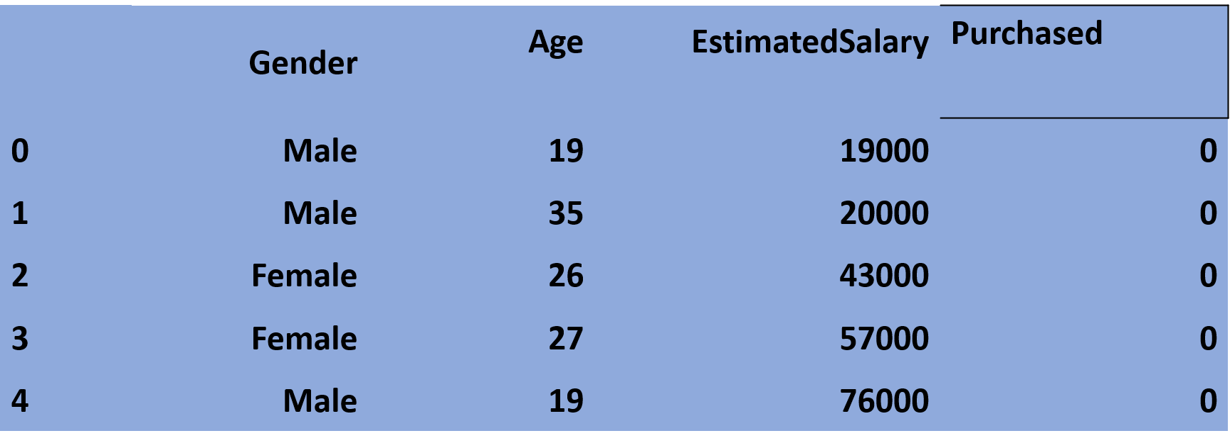
- df.head(5)
Kontruksi Prediktor Dataset

Kontruksi Prediktor Dataset

- df['Gender'] = df['Gender'].map({'Male': 1, 'Female':0})
- scaler = StandardScaler()
- df.iloc[:,1:3] = scaler.fit_transform(df.iloc[:,1:3])
- df.head(5)

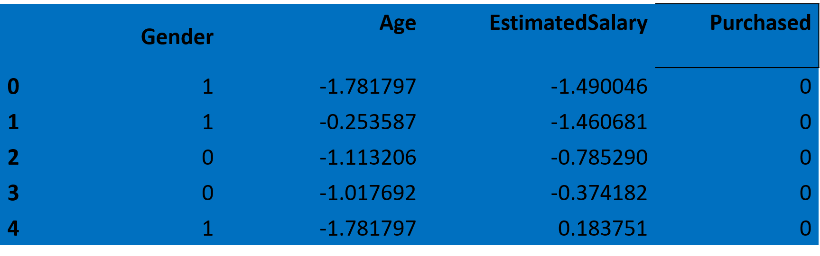

- df['Purchased'].unique()
- array([0, 1])
- df['Purchased'] = df['Purchased'].map({0:'Tidak Membeli', 1:'Akan Membeli'})
- df.head(5)
Labelling of Dataset

 | Gender | Age | EstimatedSalary | Purchased
0 | 1 | -1.781797 | -1.490046 | Tidak Membeli
1 | 1 | -0.253587 | -1.460681 | Tidak Membeli
2 | 0 | -1.113206 | -0.785290 | Tidak Membeli
3 | 0 | -1.017692 | -0.374182 | Tidak Membeli
4 | 1 | -1.781797 | 0.183751 | Tidak Membeli

- fig, axes = plt.subplots(figsize=(10,8))
- sns.scatterplot(data=df, x='Age', y='EstimatedSalary', hue='Purchased', style='Gender')
- plt.show()

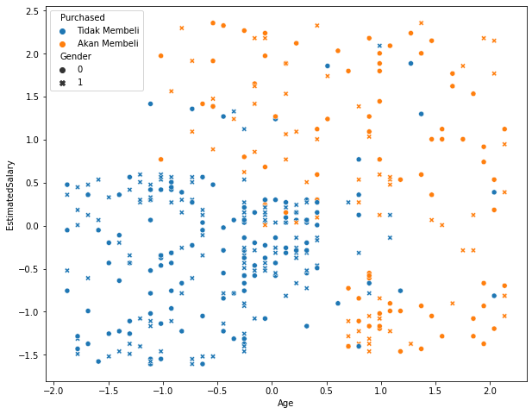
Visualization of Dataset

Model SVM
Modelling of Dataset
- X = df[['Gender','Age','EstimatedSalary']]
- y = df['Purchased']
- x_train, x_test, y_train, y_test = train_test_split(X,y, test_size=0.2, random_state=14)
- model_svm = SVC(kernel='rbf')
- model_svm.fit(x_train, y_train)
- with open('model_svm.pkl', 'wb') as file:
pickle.dump(model_svm, file)

Model LogisticRegression

- X = df[['Gender','Age','EstimatedSalary']]
- y = df['Purchased']
- x_train, x_test, y_train, y_test = train_test_split(X,y, test_size=0.2, random_state=14)
- model_lr = LogisticRegression()
- model_lr.fit(x_train, y_train)
- with open('model_lr.pkl', 'wb') as file:
pickle.dump(model_lr, file)

- y_predict = model_svm.predict(x_test)
- print(f"Classification Report \n {classification_report(y_test, y_predict)}")
Evaluation of Modelling
Classification Report
precision recall f1-score support
Akan Membeli 0.81 0.91 0.85 32
Tidak Membeli 0.93 0.85 0.89 48
accuracy 0.88 80
macro avg 0.87 0.88 0.87 80
weighted avg 0.88 0.88 0.88 80

- y_predict = model_lr.predict(x_test)
- print(f"Classification Report \n {classification_report(y_test, y_predict)}")

Classification Report
precision recall f1-score support
Akan Membeli 0.89 0.75 0.81 32
Tidak Membeli 0.85 0.94 0.89 48
accuracy 0.86 80
macro avg 0.87 0.84 0.85 80
weighted avg 0.86 0.86 0.86 80

Visualisasi Confusion Matrix
Evaluation of Modelling
- print(f"Confusion Matrix Report \n {confusion_matrix(y_test, y_predict)}")
Confusion Matrix Report
[[ 29 3]
[ 7 41]]

Visualisasi Confusion Matrix

- import seaborn as sns
- import matplotlib.pyplot as plt
- f, ax = plt.subplots(figsize=(8,5))
- sns.heatmap(confusion_matrix(y_test, y_predict), annot=True, fmt=".0f", ax=ax)
- plt.xlabel("y_head")
- plt.ylabel("y_true")
- plt.show()

